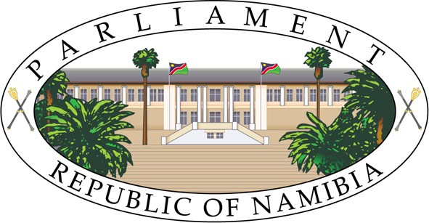

NINTH SESSION, SIXTH NATIONAL COUNCIL
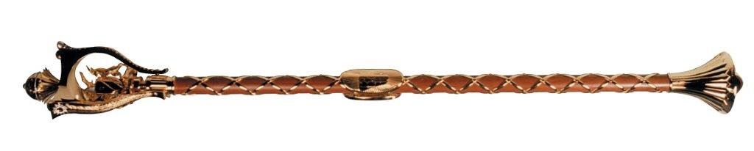

MINUTES OF PROCEEDINGS

_____________________________________________________________________
Thursday, July 06, 2023 No.19 – 2023

The Council met pursuant to adjournment.

- The Chairperson took the Chair.

- The Chairperson asked Honourable Karondo in terms of Rule 23(2), to pray and Honourable Karondo read the Prayer.

- The Chairperson read the Affirmation.

- MESSAGE FROM THE SPEAKER OF THE NATIONAL ASSEMBLY

The Chairperson announced to the National Council that the National Assembly has passed and referred the following Bills to the National Council for review in accordance with Article 75(1) of the Namibian Constitution:

- Banking Institutions Bill [B.15 – 2023];
- Companies Amendment Bill [B. 9 – 2023];
- Close Corporations Amendment Bill [B.6 – 2023];
- Payment System Management Bill [B.14 – 2023];

The Chairperson then called upon the Secretary to read the Bills a First time.

The Secretary read the Bills a First Time.

The Bills stood referred to a Second Reading.

- DEBATE ON COMMTTEE STAGE

  - FIRST ORDER READ

Debate on Committee Stage – Financial Intelligence Amendment Bill [B.2 – 2023].

The Chairperson put the question: That he leaves the Chair.

Agreed to.

The Chairperson then called upon Honourable Kauma, the Vice-Chairperson of the National Council and the Chairperson of the Committee of the Whole Council to take the Chair.

Honourable Kauma then took the Chair.

Council in Committee:

Clauses 1 to 43 were put and agreed to.

Clause 44, The Schedules 5 and 6 were put and agreed to.

Clause 44, The Short Title was put and agreed to.

Council resumed:

Honourable Kauma, the Vice-Chairperson of the National Council and the Chairperson of the Committee of the Whole Council, reported the Bill without amendments.

The Bill stood referred to Third Reading.

  - SECOND ORDER READ

Debate on Committee Stage – Prevention of Organised Crime Amendment Bill [B.11 – 2023].

The Chairperson put the question: That he leaves the Chair.

Agreed to.

The Chairperson then called upon Honourable Kauma, the Vice-Chairperson of the National Council and the Chairperson of the Committee of the Whole Council to take the Chair.

Honourable Kauma then took the Chair.

Council in Committee:

Clauses 1 to 23 were put and agreed to.

Clause 24, the Short Title was put and agreed to.

Council resumed:

Honourable Kauma, the Vice-Chairperson of the National Council and the Chairperson of the Committee of the Whole Council, reported the Bill without amendments.

The Bill stood referred to Third Reading.

  - THIRD ORDER READ

Debate on Committee Stage – Prevention and Combating of Terrorist and Proliferation Activities Amendment Bill [B.13 – 2023].

The Chairperson put the question: That he leaves the Chair.

Agreed to.

The Chairperson then called upon Honourable Kauma, the Vice-Chairperson of the National Council and the Chairperson of the Committee of the Whole Council to take the Chair.

Honourable Kauma then took the Chair.

Council in Committee:

Clauses 1 to 15 were put and agreed to.

Clause 16, the Short Title was put and agreed to.

Council resumed:

Honourable Kauma, the Vice-Chairperson of the National Council and the Chairperson of the Committee of the Whole Council, reported the Bill without amendments.

The Bill stood referred to Third Reading.

- DEBATE ON THIRD READING

  - FOURTH ORDER READ

Debate on Third Reading – Extradition Amendment Bill [B.8 – 2023].

The Chairperson put the question: That Bill be read a Third Time.

Agreed to.

The Secretary then read the Bill a Third Time.

The Bill was passed without amendments.

  - FIFTH ORDER READ

Debate on Third Reading – International Co-operation in Criminal Matters Amendment Bill [B.7– 2023].

The Chairperson put the question: That Bill be read a Third Time.

Agreed to.

The Secretary then read the Bill a Third Time.

The Bill was passed without amendments.

  - SIXTH ORDER READ

Debate on Third Reading – Virtual Assets Bill [B.12– 2023].

The Chairperson put the question: That Bill be read a Third Time.

Agreed to.

The Secretary then read the Bill a Third Time.

The Bill was passed without amendments.

  - SEVENTH ORDER READ

Debate on Third Reading – Police Amendment Bill [B.5 – 2023].

The Chairperson put the question: That Bill be read a Third Time.

Agreed to.

The Secretary then read the Bill a Third Time.

The Bill was passed without amendments.

  - EIGHTH ORDER READ

Debate on Third Reading –– Criminal Procedure Amendment Bill
[B.10 – 2023].

The Chairperson put the question: That Bill be read a Third Time.

Agreed to.

The Secretary then read the Bill a Third Time.

The Bill was passed without amendments.

- Honourable Shiimi, adjourned the Council at 10:45 until Monday, July 10, 2023 at 09:30.

Mr Tousy J. Namiseb
Secretary to the National Council

_____________________________________

