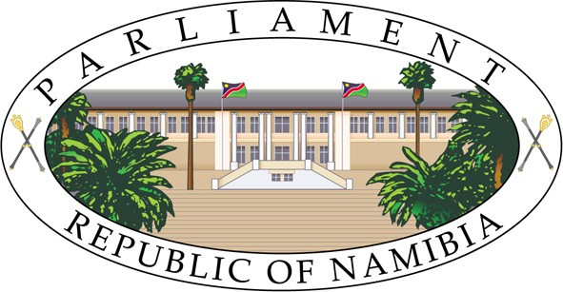

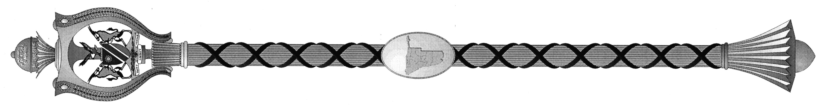
NINTH SESSION, SIXTH NATIONAL COUNCIL

ORDER PAPER
________
Monday , July 10, 2023 (09:30 – 13:00) No. 18 - 2023

ORDER(S) OF THE DAY:

- DEBATE ON SECOND READING
  - Debate on Second Reading - Banking Institutions Bill [B.15 – 2023].
  - Debate on Second Reading - Companies Act Amendment Bill [B.9 – 2023].
  - Debate on Second Reading - Close Corporation Amendment Act Bill [B.6 – 2023].
  - Debate on Second Reading - Payment System Management Bill [B. 14 – 2023].

- DEBATE ON THIRD READING
  - Debate on Third Reading – Financial Intelligence Amendment Bill [B.2 – 2023].
2.2 Debate on Third Reading - Prevention of Organised Crime Amendment Bill
[B.11 – 2023].

  - Debate on Third Reading - Prevention and Combating of Terrorist and Proliferation Activities Amendment Bill [B.13 – 2023].

_____________________________________

MONDAY, JULY 17, 2023

ORDER(S) OF THE DAY:

- DEBATE ON SECOND READING

Resumption of Debate on Second Reading – Livestock and Livestock Products Amendment Bill [B.4 – 2023] [Honourable Garab].

_________________________________

